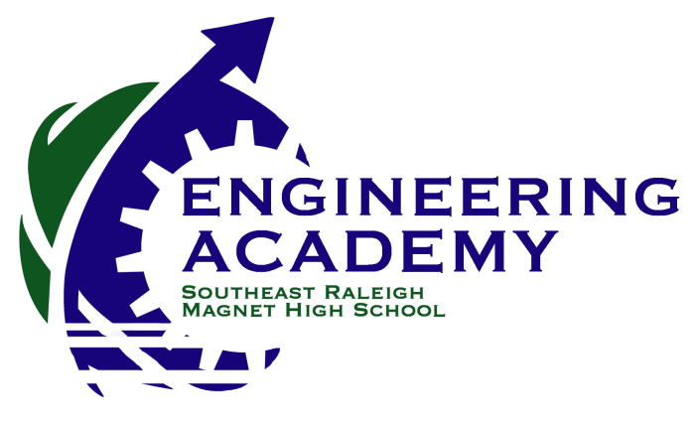

2600 Rock Quarry Road
Raleigh, NC 27610
(919) 856-2800
Welcome to Engineering at Southeast Raleigh Magnet High School!

Our students have begun a long and challenging journey toward a rewarding career as an engineer. The Engineering Academy’s Advisory Board is dedicated to working with the Academy to help ensure that this journey is successful. The Advisory Board was formed last year and includes both parents and engineering professionals. Our goals for the coming year include:
- hosting a family night each semester to display student projects;
- creating a guest speaker list that teachers can utilize;
- recruiting additional firms for job shadowing, field trips, and internships;
- developing a web site to create awareness and community;
- recruiting incoming freshmen for the 2013-2014 year.
- filing 501(c)(3) application for non-profit status ($400 fee – accomplished)
Please help us achieve these goals by filling out the form below and returning it to our Engineering Academy Coordinator, Jennifer Varahala at jvarahala@wcpss.net. You can also e-mail our chair, Rich Lemert, at rlemert@mindspring.com, for more information. Please note that you don’t need to be an engineer to join us; parents are eligible for full membership on the Advisory Board.

Thank you!
SRMHS Engineering Advisory Board
---------------------------------------------------------------------------------------------------------------------------
Name: Company:
We are interested in providing (circle):
guest speaker(s) field trip(s) job shadowing mentoring internship(s) – highly needed
We would be interested in helping the Advisory Board with (circle):
web site family nights recruitment student workshops (mock interviews, workforce
etiquette, or specialty trainings)
We are interested in serving on the Advisory Board (circle): YES NO
We are donating $ to help with any expenses that are in alignment with the board’s goals (new equipment for classrooms, student field trips, hosting school events, TSA competition, FIRST Robotics Competition, scholarships for our students, and etc). Checks should be made payable to “SRMHS Engineering Academy Advisory Board”.

Additional Comments or Suggestions:

